NIHVA Machine protection High speed door

Our machine protection doors are meticulously engineered to serve as a vital safety barrier between operators and hazardous machinery. Specifically designed for environments housing laser processing machines, robotic welding cells, and high-speed automated production lines, these doors offer unparalleled protection and peace of mind.
Key Features:
- Robust Construction: Crafted from high-quality materials, our machine protection doors ensure durability and reliability in demanding industrial settings.
- Enhanced Safety: Engineered with advanced safety features, including sensors and interlocks, to prevent unauthorized access and ensure operator security.
- Seamless Integration: Designed to seamlessly integrate into existing machinery setups, our doors offer effortless installation and operation.
- Customization Options: Tailored to meet your specific requirements, with options for size, materials, and control systems to suit your unique application.
- Compliance Assurance: Manufactured to meet or exceed industry safety standards and regulations, ensuring full compliance with safety guidelines.
Industries :
- Manufacturing
- Welding
- Metalworking
- Automotive
- Aerospace
- Laser Processing
- Packaging
- Pharmaceuticals
- Food Processing
- Textiles

- Technical specification
Use | Internal door |  | Standard
Door size | Max width  Max height |  | 5000ṁm  4000mm
Speed | Opening speed (up to)  Closing speed (up to) |  | 2.2m/s  1.8 m/s
Standards | EN 13241-1:2004-04  DIN EN 12978:2009-10  PrEN 12453:2014-06 |  | Standard
Resistance to wind load | EN 12424 |  | Up to class 1
Safety switch for closed end position | One switch, non-contact, coded PL e / SIL CL 3  Second Switch |  | Standard  Optional
Curtains | Monoflament 2.0 mm  Transparent PVC section 2.0mm ( 500*700 mm one pc. window) Transparent PVC section second window / full vision |  | Standard  Standard  Optional
Guide Material / Surface | -10℃ + 70℃  Aluminium anodized  Painting in any RAL colour |  | Standard  Optional
Soft/ cover surface  Operator & Control Panel | Structure powder coating RAL9006  Structure powder coating any RAL Colour |  | Standard  Optional
Operator & control panel | Connection voltage |  | 220V – 1ph,N
Operator & control panel | Open-Stop-Close Button |  | Standard
Operator & control panel | Protection Category (Operator/Control) |  | IP 54 / IP 65
Operator & control panel | Emergency off Button |  | Standard
Operator & control panel | Maintenance Switch |  | Standard
Operator & control panel | Closing Zone Monitoring  - Optical side Edge  - Light Curtain |  | Optional  Standard
Operator & control panel | External route monitoring (Photocell) |  | Standard
Operator & control panel | Door area monitoring  - Radar Presence Detector  - Induction loop |  | Optional  Optional
Operator & control panel | Electronic Limit Switch |  | Standard
Emergency Opening | Crank Handle  Chain |  | Standard  Optional
Standard curtain colours |   Blue Similar to RAL 5010 |   Orange Similar to RAL 2004

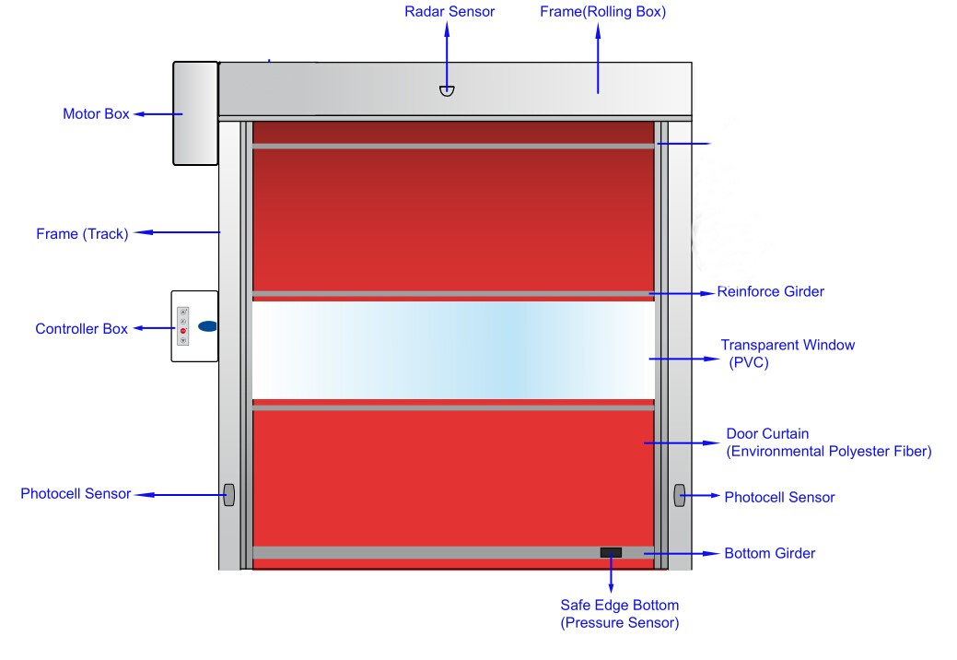
General Drawing

TECHNICAL DATA | ASSA ABLOY RP300
Application | Interior door / Machine Protection door
Door dimensions (mm) (DW min./max.) (DH min./max.) | 750 / 4000 mm 750 / 3500 mm
max. area | 14 m²
Opening direction | Vertical (Standard)
Wind resistance (EN 12424) | class 1 (max. 11 m²) (Standard)
Noise emission | < 70 dB A (Standard)
Temperature range max. (Extended on request) 3 | +10°C – +45°C (0 up to +60°C)” (Standard)
Surface material
Side frame | ⎫ Anodized aluminium (Standard)
Top roll cover | • Anodized aluminium (Optional)
Bottom profile | ⎫ Anodized aluminium (Standard)
Motor cover | • Powder coated steel, RAL 9006 (Optional)
Extension side frame | -
Safety features
Electrical safety contact edge | Standard
Door line photocell | Standard
Pre-running photocell (only in combination with MCC, Door line photocell as option) | Optional
Flush bottom profile | Optional
Drop down protection in drive unit | Standard
Pre-running photocell 2) | -
Emergency egress | Crank handle (Standard)
Counterbalance | -
Equipment
LED traffic light | Optional
Traffic light / Flashing alarm light | Optional
Suitable machine protection | Optional
Magnetic switch in side frame | Optional
Window in side frame, view on magnetic switch | Optional
Drive unit
Motor power | 0,75 kW (Standard)
Chain drive | Optional
Gear heating | Optional
Control system | ACS 50 / • MCC (Standard)
Control system
MCC Open/Close max. (m/s) 2) | 2,4 / 1,3 2,4 / 1,75 (pre-running photocell) (O)
ACS 50 Open/Close max. (m/s) 2) | 1,0 / 1,0
Cycles per minute max. * exact number of cycles depending on application | ACS 50 = 1 MCC = 3 up to 5*
Separate display / contra | only at MCC
Fuse protection by site | 10 A (C-characteristic) (at 220/230V 16 A)
Control voltage | 24 V DC
Protection | IP 55
Potential-free contacts | Optional
UL-Version | • ACS50 • MCC (Optional)
Network connection
ACS 50 | Standard: 3L/(N)PE/220/230/380/400/415V; 50Hz with transformer: 3L/(N)PE/440/480/500V; 50Hz  UL-Version: 3L/(N)PE/208/220/230/460/480V; 60Hz
MCC | Standard: 3L/(N)PE/380/400/415/440/460/480V;50/60Hz with transformer: 3L/(N)PE/220/230/500V;50Hz UL-Version: 3L/(N)PE/208/220/230/460/480V; 60Hz

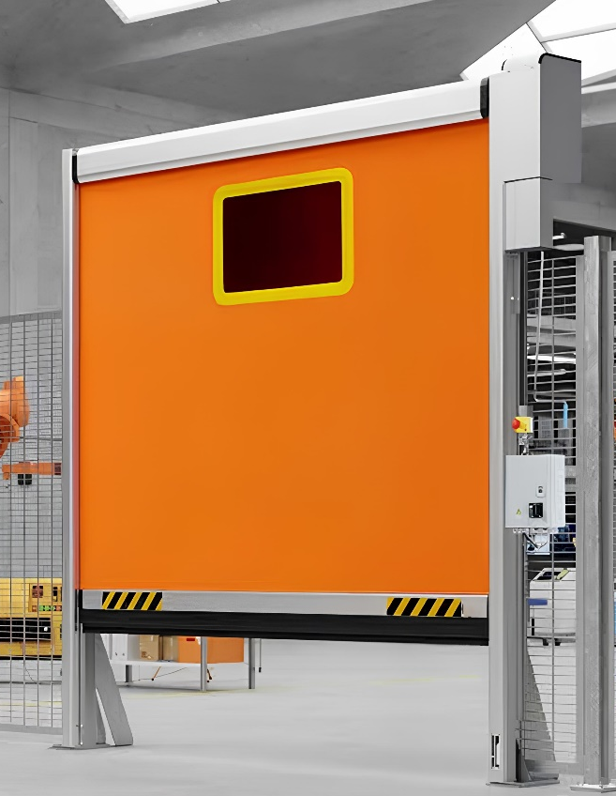
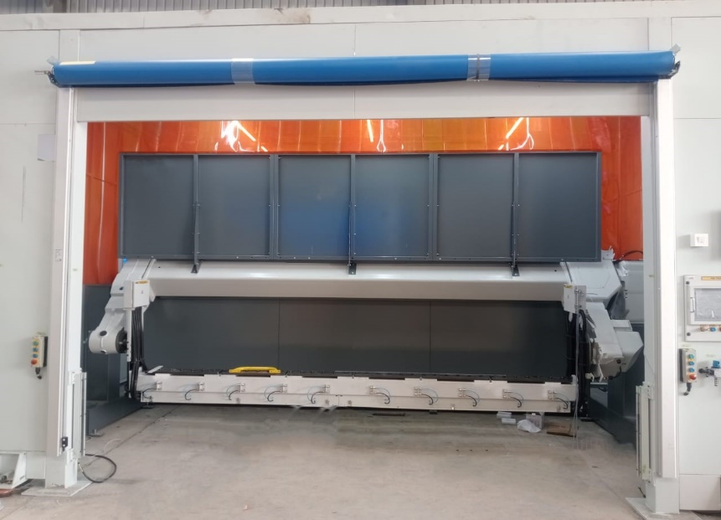

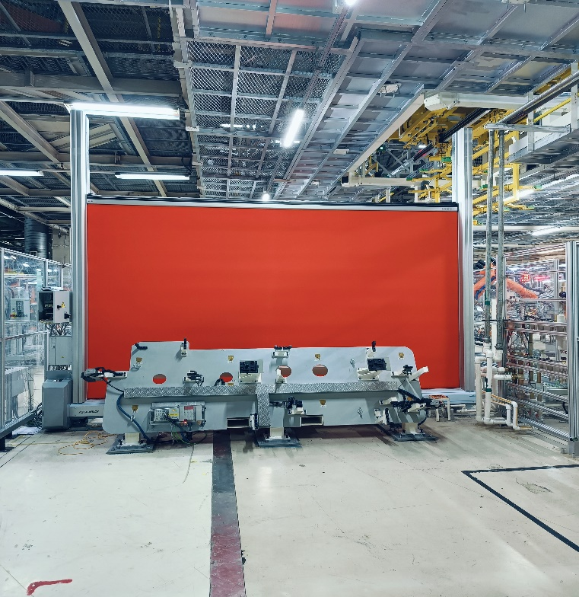
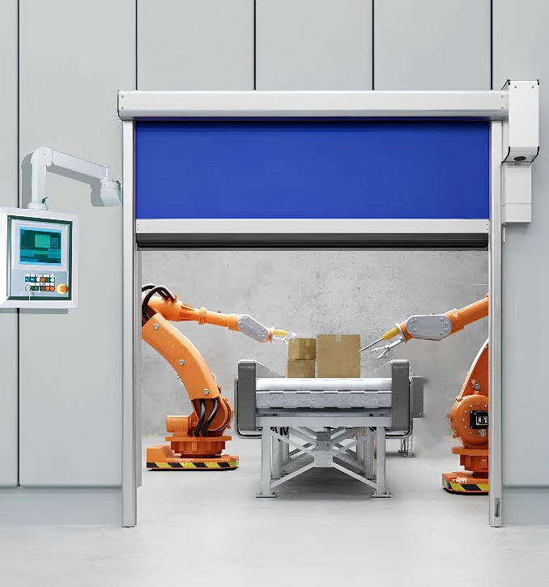
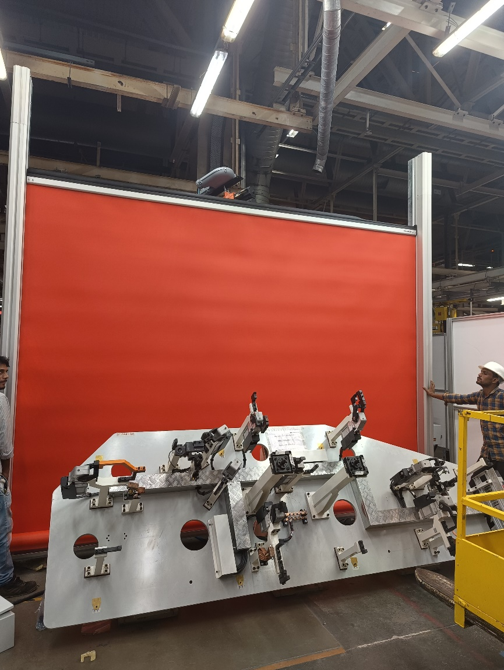
Other Accessories : -
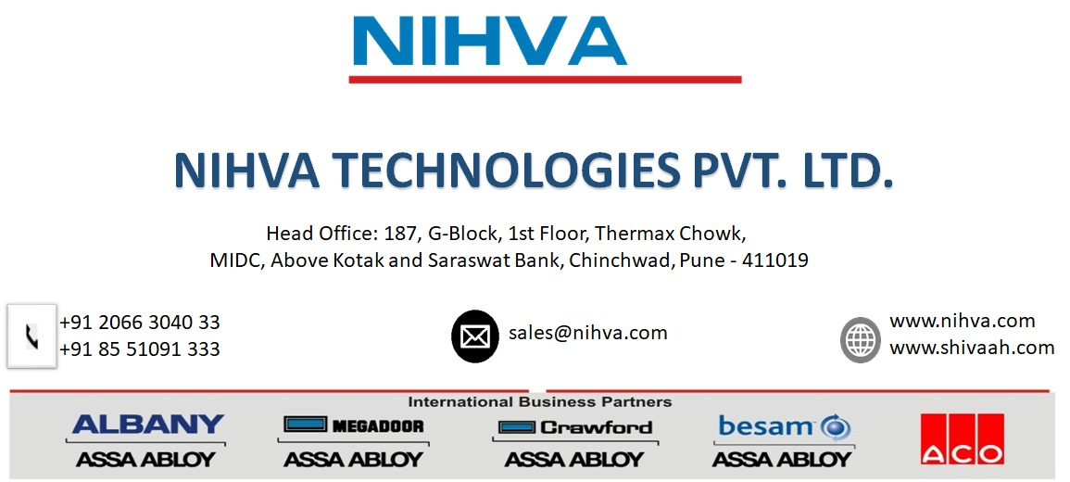
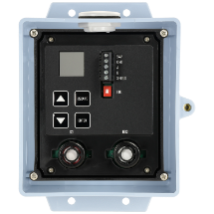
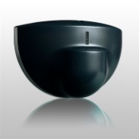
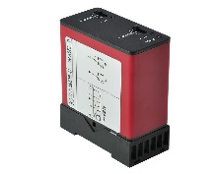
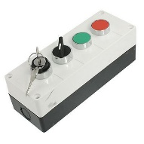
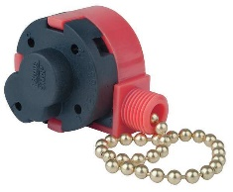
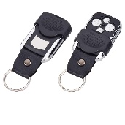
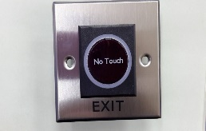
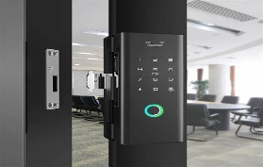
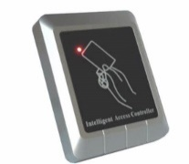
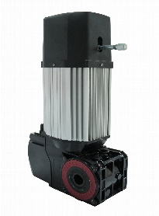
Motion sensor
No touch switch
Pull cord

3 way Push button
Loop dictator
Panel control
Biometric system

Remote
RFID card sensor
High speed Motor

